Radio Telescope Project

Shoreditch College 1961–1963

A Project outside the Curriculum
The idea for constructing a Radio Telescope (RT) was introduced by the Rural Studies Lecturer to our class in the Fall of 1961. He believed that Rural Studies should encompass activities outside the traditional Rural Studies curriculum. The Rural Studies lecturer had a magazine that included an article on radio astronomy by an amateur radio astronomer operating his RT site at the (Frank) Hyde Radio Observatory. This article included a circuit diagram for the high frequency receiver (possibly 60Mc/s), a circuit diagram for the power supply and construction details of the aerial and its wiring.

I had just left the Royal Air Force and had a background in electronics, so with a small group of students and the support of the lecturer, it was decided to go ahead and build the RT. To get the project started, the lecturer arranged for the group, including myself, Stan Instone, I believe Johnny Williams and another student to visit the Hyde Radio Observatory.

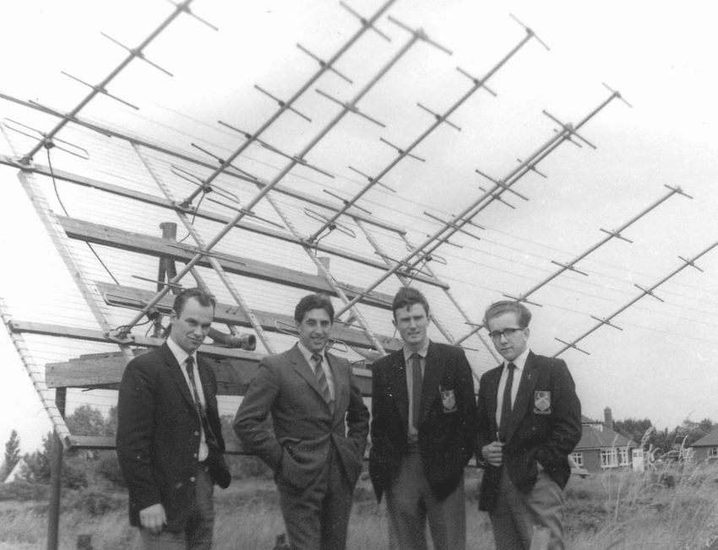
Photo 1. Hyde Radio Observatory
Student, Stan Instone, Neville Webb, John Williams

At the RT site, the electronic equipment was inside a Martello tower, with the aerial arrays in the open nearby (Photo 1.) An important part of the RT set-up was a pen-recorder to show the strength and variation of received signal outbursts (Photo 2.).

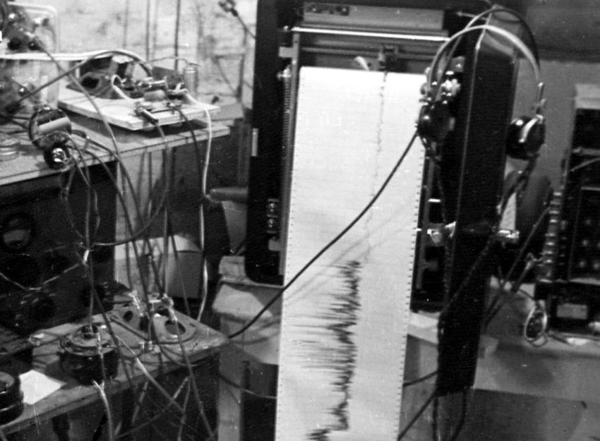
Photo 2. Pen Recorder - Hyde Radio Observatory
Buiding the Project
The Aerial
Constructing and wiring the aerial array presented little difficulty (Photo 3.). The aerial (not shown) used chicken wire mesh as a reflector, and the half-dipole aerials were strung one half-wavelength above the mesh. The aerial array rotated fully in azimuth, and from the vertical through to fully overhead

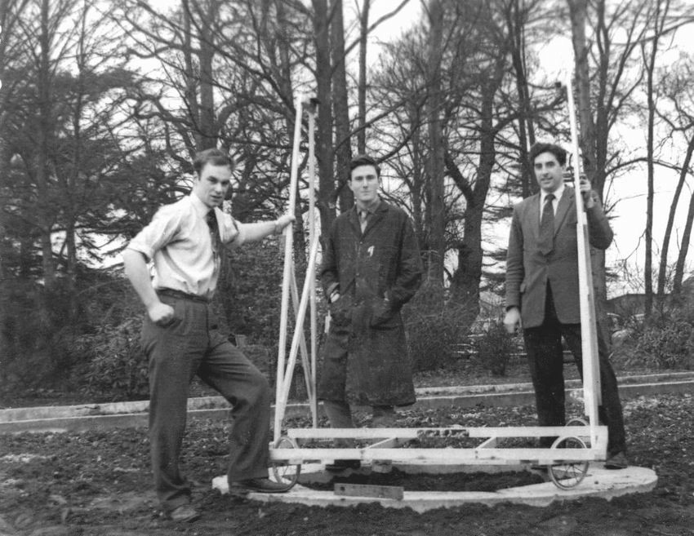
Photo 3. Turntable and Aerial support frame.
Student, Neville Webb, Stan Instone

The Receiver
Building the receiver (Photo 4a.) required electronic tubes (valves) to be sought, which did present some problem. The wiring and component assembly had to be carefully done without the benefit of an Avometer or a voltmeter.

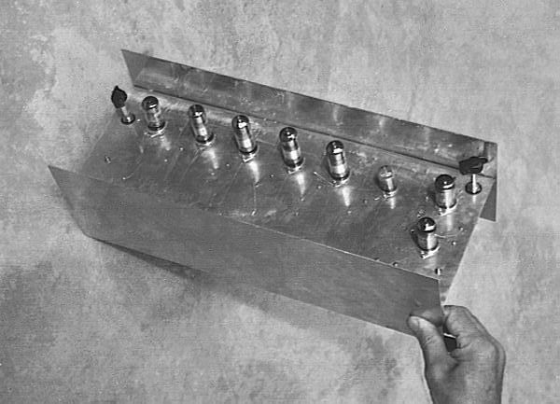
Photo 4a. Receiver unit.

Operating at such a high frequency, care was needed in wiring the receiver; each of the four main amplification stages had to be fully screened from the others; grounded screened wire was used to carry the signal from one amplification stage to the next stage (Photo 4b.).
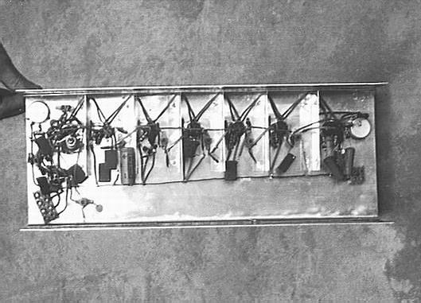
Photo 4b. Receiver unit, wiring for application stages.

The output from the receiver was through a loudspeaker taken from a television set. It should be realized that such a project was outside the traditional college curriculum and did not seem to have any support beyond the Rural Studies department. A key item was the necessary
pen-recorder, however a budget could not be made available to obtain this item.

The rectified power supply presented more of problem since the wiring diagram was either incorrect or a mistake was made .. a blue flash was the result when it was plugged in to the electrical mains supply. So, with the aerial built and an untried receiver, for a while the RT project came to a halt.

Continuing the Project
By the end of 1962 college work was beginning to take up more time, and the RT project was on our own time without course credit. Later another student wired up the power supply, I believe with the same result as before. From what I recall, the Rural Studies lecturer had the power supply rewired locally, and it was hooked to the receiver. With this done it was possible to test the receiver, simply by adjusting the variable coil in each amplification stage .. a hit or miss affair at the best.

One late evening, I believe in the Fall of 1963 or later, I went down to Rural Studies and the aerial was hooked to the receiver. After adjusting each of the tuning coils, again a hit or miss affair, a feint but clear audio signal was heard. This signal seemed to be from a commercial television transmission. So there the project rested. I did gather during a visit to the College, that sometime later a pen-recorder was made available.

Conclusion
Perhaps with the traditional curriculum in place in the College, a project such constructing a building a radio telescope was a little ahead of its time. With the changeover to technology based education and project design, such projects should be encouraged either at the teacher training level, or using suitable resources within schools.

Neville Webb 24th September 2007

